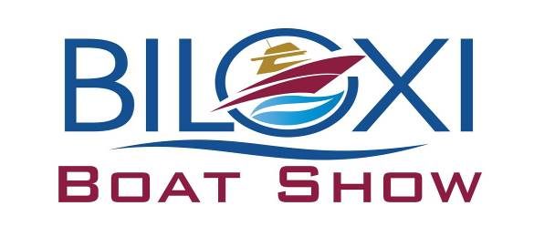

We are looking forward to another great show in Biloxi! Please find the enclosed information packet with layout and contract for the Biloxi Boat Show February 6-8, 2026 at the Mississippi Coast Coliseum and Convention Center. Information regarding booth supplies and move-in schedule will be available upon receipt of signed contract, deposit and proof of insurance. All forms are also available online under the Biloxi Boat Show tab at www.gulfcoastshows.com

Show Hours: Friday, February 6 10am – 7pm
Saturday, February 7 10am –7pm
Sunday, February 8 10am – 5pm

Move in dates: Dealers: February 3-5
Booths: February 5-6

Move out dates: End of show February 8-9

ALL EXHIBITORS MUST PROVIDE A CERTIFICATE OF LIABILITY INSURANCE NAMING GULF COAST SHOWS AS ADDITIONAL INSURED

Dismantling of booths and exhibits before close of show on Sunday will forfeit your space in the next year’s show.

Space assignment will be determined upon receipt of signed contract and deposit. If you have any questions or need any additional information please call Melissa Miller 251-377-6328 email: melissa@gulfcoastshows.com and Mary Blan Boggan 251-604-2153 email: maryblan@gulfcoastshows.com. You can also visit
our website at www.gulfcoastshows.com

Follow the Biloxi Boat Show on Facebook and Instagram!

