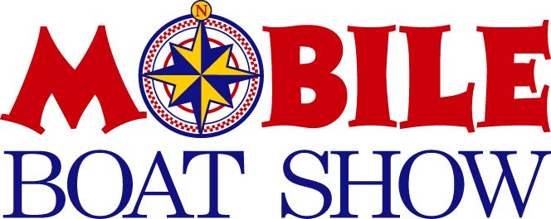

We are looking forward to another great show in Mobile! Please find the enclosed layout and contract for the 2026 Mobile Boat Show February 27th – March 1st at the Mobile Convention Center. You will receive information regarding host hotel, tickets, space assignment, move-in schedule and badge form upon receipt of signed contract and deposit. Forms and information are also available online closer to the show under the Mobile Boat Show tab at gulfcoastshows.com

Show Hours: Friday, February 27 10am – 7pm
Saturday, February 28 10am – 7pm
Sunday, March 1 10am – 5pm

Move in dates: Dealers: February 23-26
Booths: February 26-27

Move out dates: End of show March 1 - 2

For information and forms to order electricity, phone, water and on-line services please go to the Mobile Convention Center’s website mobileconventions.com. Make sure you confirm your space before ordering.

ALL EXHIBITORS MUST PROVIDE A CERTIFICATE OF LIABILITY INSURANCE NAMING GULF COAST SHOWS AS ADDITIONAL INSURED

Dismantling of booths and exhibits before close of show on Sunday will forfeit your space in the next year’s show.
Space assignment will be determined upon receipt of signed contract and deposit. If you have any questions or need any additional information please call or email:

Mary Blan Boggan (251) 604-2153 maryblan@gulfcoastshows.com or
Melissa Miller (251) 377-6328 melissa@gulfcoastshows.com

Follow the Mobile Boat Show on Facebook and Instagram!

